Researchers information (Chief Investigator): Dr TY Lee; 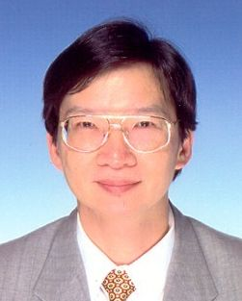
Academic and Professional Achievements:
Ph.D., M.Sc., MBA, MA, C.Eng, MIMechE, MIE (Aust)
Working Experience:
Director, Technology Support Centre, The University of Hong Kong (1989-2008)
Lecturer, Regency College, South Australia (1987-88)
Lecturer, Nanyang Technological Institute, Singapore (1983-86)
Selected Publications:
- Lee T.Y., Taoism, Confucianism, Legalism and ISO 9000: A Managerial Perspective, International Journal of Management. England, 2001, 18(4): 515-522. (Publication No. : 73703)
- 李達義，從「道可道，非常道」看管理之道，信報月刊，2003年6月號
- Lee T.Y., Development of Management Philosophy for Chinese Business Environment, Management Decision, England, 2005, 43(4)

Teaching, Training and Consultancy Experience:
- The University of Hong Kong: Broadening Course “Quality in a developed economy”, 2005 – 2007.
- Hongkong Electric: In-house Training Workshop on “Management – East Meeting West”, 6/2006
- The University of Hong Kong: Seminar on “Management and Traditional Chinese Wisdom”, 1/2002, 1/2003, 10/2003, 9/2004, and 7/2005

Quality Management Award Assessment:
- 1997 to 2005, Chairman of the Board of Examiners, Quality Award organized by Hong Kong Management Association.
- 2007-2009, Examiner, Departmental Service Enhancement Award, Hong Kong SAR Government.2007, Chairman of the Board of Assessors, Business Leadership in Quality Award, Chartered Quality Institute Hong Kong Branch.

